WEBSITES TO PRACTICE AUTOMATION OR CREATE AUTOMATION DEMOS

Many times, when we are learning web automation, a thing to consider that is often ignored is where to start practicing interactions with web elements. As much as pages like Google or Amazon are great sites to test one’s automation abilities, these websites can be intimidating for newcomers. That’s why today we will be talking about some websites specially designed for ‘Test Automation’ so anyone interested in starting to get familiar with it or putting to test their skills will have a good road to work on.

SauceDemo.com

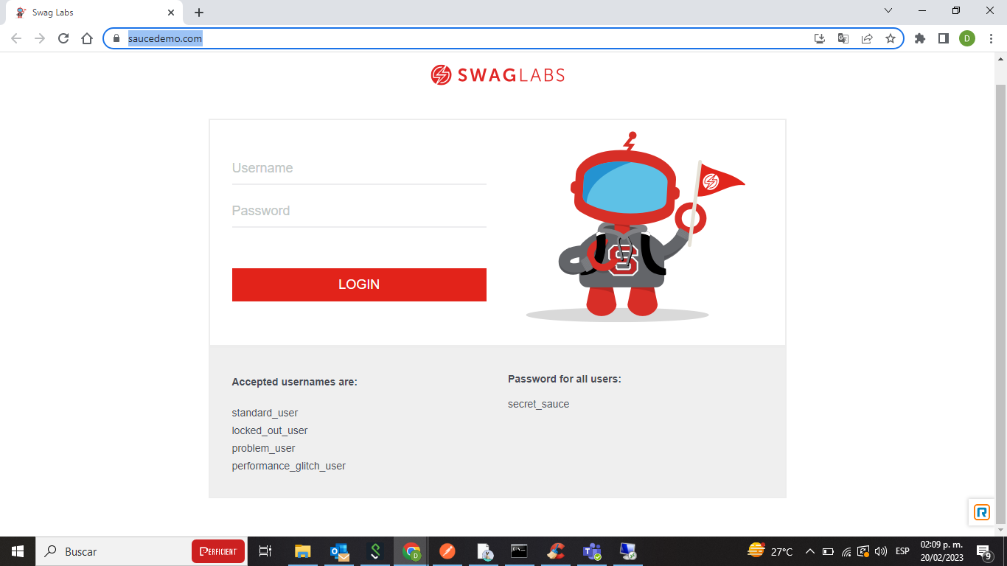

This site is an E-commerce (mock) website. The web elements are well-defined and use a lot of different attributes, a good thing when starting. The user can get familiar with how different location methods work on these elements (e.g., byCss, byXpath, byClass, byAttribute).

Another great feature of this website is that it provides different types of users like the ‘problem_user’ which will have issues with the app, making many of the test cases fail expectedly, or the locked_out_user, which can be useful to hand in our code these type of alerts/errors a page can throw us on the login page.

No doubt www.saucedemo.com is one of the best websites to practice Test Automation for anyone no matter their level of knowledge.

ultimateqa.com/automation

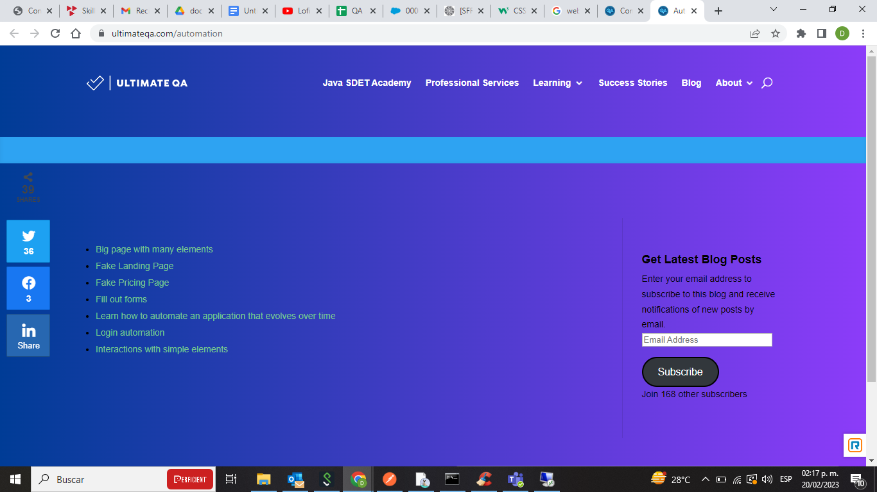

This Automation QA website provides us with multiple options or types of applications to work out our automation skills; users can choose between a ‘Big page with many elements’ or an ‘Application that evolves over time’.

No doubt, the versatility that this website offers is a great thing for any automation enthusiast or automation engineer searching for test websites to practice their code skills or to use as didactic material.

Telerik.com

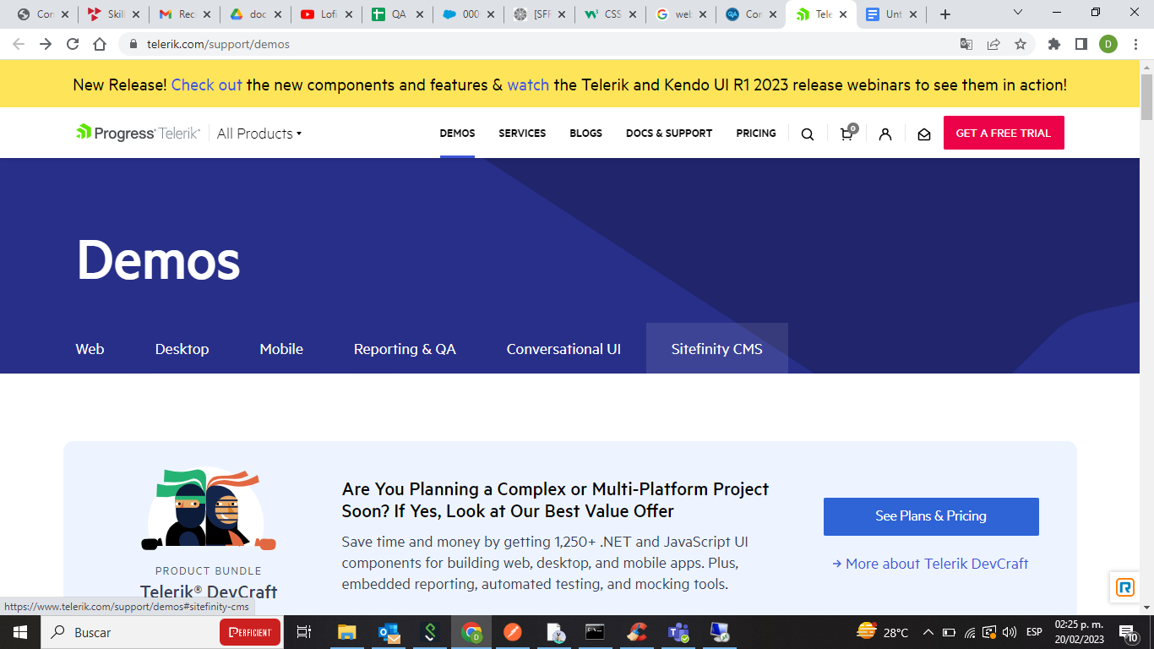

Telerik provides demo services that can be acquired via subscription, but besides the fact that the page itself it’s a great automation testing website, the user can get familiar with Angular and REACT components working on this site which in today’s industry are a must.

These are a few of the websites I thought could be useful for anyone in need of a good automation testing website or just a playground to work out one’s skills or educate others on the art of automation testing and getting comfortable with UI elements and frameworks such as Angular and REACT. I hope this article was helpful and stay tuned for more automation tips and tricks.

